MATLAB Homework I

Matlab Code:

#1🡪 t=-10:0.1:10; % t=-10,-9.9,-9.8 … 9.8,9.9,10

#2🡪 y=5\*cos(0.3\*pi\*t+1.2\*pi); % this is formula (slide 19)

#3🡪 plot(t,y) % plot is a drawing function. t and y for plot axis.

Screenshot:

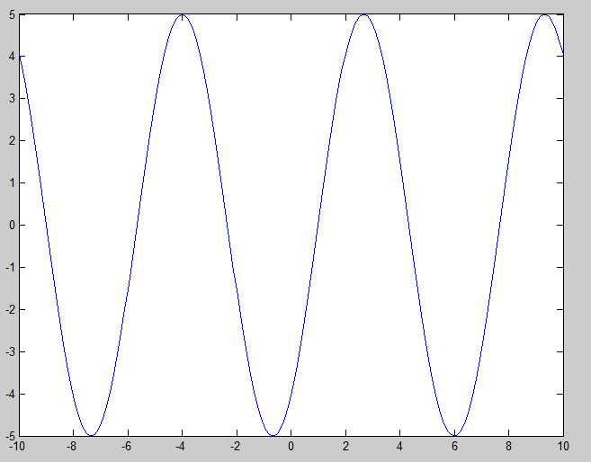

Name and Surname : Sıddık Said AYDOĞAN

Number: 11011052

Date: 30.09.2013